TEACHERS’ PROGRAMME ON PREVENTION OF EARLY SCHOOL LEAVING
MAYO EDUCATION CENTRE
MODULE 2 – COMMUNICATION

March 24th 2009

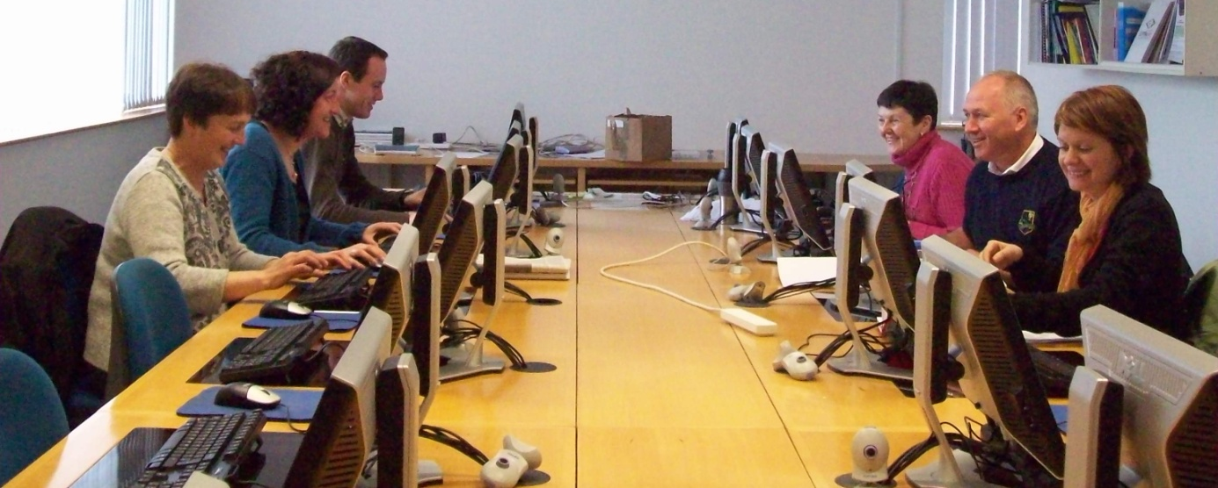

The session to explore Module 2 was conducted by Ann Caulfield and Art O Súilleabháin form Mayo Education Centre

PRESENT on the day were:

Ms Marie Verity
Ms Rosaleen Sullivan
Mr Daniel Forde
Mr Denis O’Boyle
Ms Josephine McDonagh
Ms Sarah Sheridan
Ms Philomena Browne

Discussion on Module 2 in Mayo indicated that the module was very thorough, well structured & presented and easy to follow.

The general impression was that it is a very comprehensive piece of work on a broad range of communication techniques. It was clear that some of the techniques could be used in many situations of communicating as well as to explore responses to students considering leaving school early.

On the whole, communication was considered to be the most important aspect of dealing with the issue of early school leaving and the requirement of sensitive and clear communication valuable in all interactions with students.

The practical examples given in this module were considered beneficial and the many work sheets e.g. Truants – Buddys needed and ‘I’ Statements were appreciated. These are easily accessed and useful to use with students.

Discussion took place regarding the involvement of parents in the issue of absenteeism and subsequent potential for such students to leave formal education. The sections 'Preparing for conversations with pupils and parents' and 'Carrying out conversations with pupils and parents' were particularly named as being useful in this regard, as it was noted that dialogue between parents and teachers can often be difficult to negotiate.

In short...

STRENGTHS

Clear outline of information
Comprehensive study on communication tools, styles,
Interaction with the issue of early school leaving and concrete examples of communicating with students and parents
The module encourages teachers to re-assess the importance of communication and the value of it in teacher training as in the class room
Sections referring to parents and the counselling section

WEAKNESSES
The document has such comprehensive information – it is very detailed and may bee too much at one go

OPPORTUNITIES
This module could be used in a wonderful variety of settings – both educational, training, in personal development with students, and for teachers themselves
It might be useful to have a shorter version with bullet points and more clarity

THREATS
The amount of detail may be confusing – and yet there is nothing we would leave out!

Congratulations – a great resource...
